**A REPORT**

**ON**

**POINT TO SITE (P2S) VPN DEPLOYMENT VIA AZURE**

Submitted in partial fulfillment of the requirements

for the award of the Degree of

**Bachelor of Technology**

**of**

**Poornima University, Jaipur**



**Submitted By:**

**Manish Jangid………………………………………2017PUSETBCCX05847**

**Meetaksh Dadhich………………………………….2017PUSETBCCX05724**

**Khanak Sharma…………………………………….2017PUSETBCCX05721**

**Kapil Saratkar………………………………………2017PUSETBCCX05752**

**Khushbu Joshi………………………………………2017PUSETBCCX05685**

**IIIrd Year, Computer Engineering(CT & IS )**

**Submitted To:**

**Dr. Nitesh Kaushik, Asst. Professor**

**Department of Computer Engineering** **School of Engineering & Technology, Poornima University Ramchandrapura, Sitapura Ext., Jaipur, Rajasthan**

**Session: 2019-20**

**ACKNOWLEDGEMENT**

We have undergone a project development which was meticulously planned and guided at every stage so that it became a life time experience for us. This could not be realized without the help from numerous sources and people in the Poornima University.

We are thankful to **Dr. Manoj Gupta, ProPresident, Poornima University** for providing us a platform to carry out this activity successfully.

We are also very grateful to **Mr. Ravi Godara (HOD, Computer Engineering)** for his kind support and guidance.

I would like to take this opportunity to show our gratitude towards **Dr. Nitesh Kaushik & Mr. Tushar Mittal** who helped us in successful completion of my seminar. They have been a guide, motivator & source of inspiration for us to carry out the necessary proceedings for completing this project and related activities successfully and grateful for their guidance and support. We are thankful for their kind support and providing us expertise of the domain to develop the project.

We would also like to express our hearts felt appreciation to all of our friends whom direct or indirect suggestions help us to develop this project and to entire team members for their valuable suggestions.

Lastly, thanks to all faculty members of Department of Computer Engineering for their moral support and guidance.

**Manish Jangid**

**Meetaksh Dadhich**

**Khanak Sharma**

**Kapil Saratkar**

**Khushbu Joshi**

iii

|  |  |
| --- | --- |
|  | **2019-20** |
|  |  |

**Abstract**

Point to Site VPN connection allows a customer to create a secure SSTP (Secure Socket Tunneling Protocol) connection to his/her virtual network from an individual **Client Computer**. P2S connections can be used in conjunction with S2S connections through the same VPN gateway, provided that all of the configuration requirements for both connections are compatible. Point to site connection only supports Maximum 128 VPN Clients connection at a same time.

In this Project, we will focus on how to connect our local network to our Azure Virtual Network. To reach this goal, we will perform the following steps:

* Create a Resources Group
* Create a Virtual Network
* Create a VPN Gateway\

– As described by Microsoft: *“A VPN gateway is a specific type of virtual network gateway that is used to send encrypted traffic between an Azure virtual network and an on-premises location over the public Internet.”*

* Create a Gateway subnet / Virtual Network Gateway

– As described by Microsoft: *“A virtual network gateway is composed of two or more virtual machines that are deployed to a specific subnet you create, which is called the gateway subnet. Virtual network gateway VMs are configured to contain routing tables”*

* Create Root and Client Certificates
* Configure a Point-To-Site Connection
* Testing the VPN Connection

**Poornima University, Jaipur** **B.tech, Computer Engineering(CT & IS)**

|  |  |
| --- | --- |
|  | **2019-20** |
|  |  |

**TABLE OF CONTENTS**

|  |  |  |  |
| --- | --- | --- | --- |
| **Cover Page** | |  | **i** |
| **Acknowledgement** | |  | **ii** |
| **Abstract** |  |  | **iii** |
| **Table of Contents** | |  | **iv** |
| **List of Tables** | |  | **v** |
| **List of Figures** | |  | **vi** |
| **Chapter 1- Introduction………………………………………….** | | **1-2** | |
| 1.1 | Aims and Objectives……………………………………………………. | | 1 |
| 1.2 | Scope……………………………………………………………………. | | 1 |
| 1.3 | Technology used…………………………………………………….. |  | 1 |
| 1.4 | Technical Requirements…………………………………………………. | | 2 |
| **Chapter 2- About Technology ………………………………..** | | **3-5** | |
| 2.1 | Introduction ……………………………………………………………3 | |  |
| 2.2 | History……………………………………………………………… |  | 3 |
| 2.3 | Key Components…………………………………………………………4 | |  |
| 2.4 | Current Trends in Today’s World ………………………………………… | | 5 |
| **Chapter 3- Technological Details/Architecture …………..…..** | | **6-33** | |
| 3.1 | Technology Overview…..………………………………………………. | | 8 |
| 3.2 | Design……….……………………………………………............ | 10 |  |
| 3.3 | Architecture…………………………………………………….......….. 20 | |  |
| 3.4 | Implementation……………………………………………………… | 25 | |
| 3.5 | Applications & Limitations………..………………………………… | 33 | |
| **Chapter 4-Miscellaneous, Conclusion & Future scope…………** | | **34-37** | |
| 4.1 | Conclusion…………………………………………………………. | 36 | |
| 4.2 | Future Scope…………………………………………………… | 37 | |

**References……………………………………………………………….**



**Poornima University, Jaipur** **B.tech, Computer Engineering(CT & IS)**

|  |  |
| --- | --- |
|  | **2019-20** |
|  |  |

**Chapter 1**

**Introduction**

* 1. **Aims and Objective:**

A Point-to-Site (P2S) VPN gateway connection lets you create a secure connection to your virtual network from an individual client computer. A P2S connection is established by starting it from the client computer. This solution is useful for telecommuters who want to connect to Azure VNets from a remote location, such as from home or a conference. P2S VPN is also a useful solution to use instead of S2S VPN when you have only a few clients that need to connect to a VNet.

Unlike S2S connections, P2S connections do not require an on-premises public-facing IP address or a VPN device. P2S connections can be used with S2S connections through the same VPN gateway, as long as all the configuration requirements for both connections are compatible.

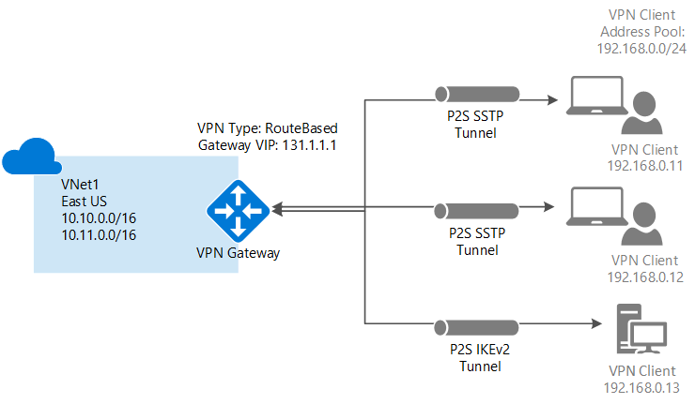

**1.2 Scope:**

**Point-to-Site** (VPN over SSTP) configurations let you connect from a single computer from anywhere to anything located in your virtual network. It uses the Windows in-box VPN client. As part of the Point-to-Site configuration, you install a certificate and a VPN client configuration package, which contains the settings that allow your computer to connect to any virtual machine or role instance within the virtual network. It's great when you want to connect to a virtual network, but aren't located on-premises. It's also a good option when you don't have access to VPN hardware or an externally facing IPv4 address, both of which are required for a Site-to-Site connection.

You can configure your virtual network to use both Site-to-Site and Point-to-Site concurrently, as long as you create your Site-to-Site connection using a route-based VPN type for your gateway. Route-based VPN types are called dynamic gateways in the classic deployment model.

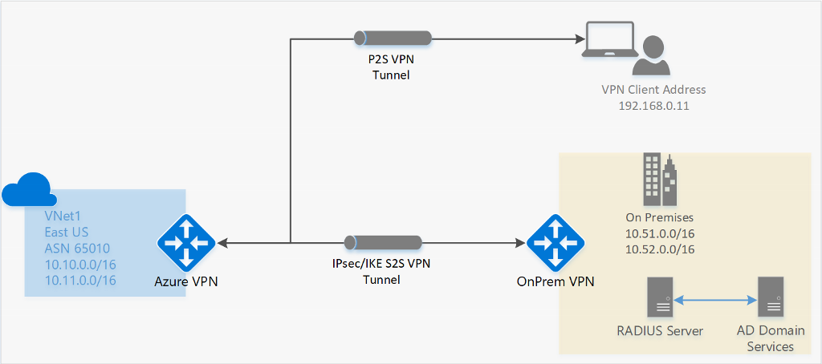

* 1. **Technology used**

**Microsoft Azure** is a [cloud computing](https://en.wikipedia.org/wiki/Cloud_computing) service created by [Microsoft](https://en.wikipedia.org/wiki/Microsoft) for building, testing, deploying, and managing applications and services through Microsoft-managed [data centers](https://en.wikipedia.org/wiki/Data_center). It provides [software as a service (SaaS)](https://en.wikipedia.org/wiki/Software_as_a_service), [platform as a service (PaaS)](https://en.wikipedia.org/wiki/Platform_as_a_service) and [infrastructure as a service (IaaS)](https://en.wikipedia.org/wiki/Infrastructure_as_a_service) and supports many different [programming languages](https://en.wikipedia.org/wiki/Programming_language), tools, and frameworks, including both Microsoft-specific and third-party software and systems.

## **Connect your datacenter to Azure**

Azure VPN Gateway connects your on-premises networks to Azure through Site-to-Site VPNs in a similar way that you set up and connect to a remote branch office. The connectivity is secure and uses the industry-standard protocols Internet Protocol Security (IPsec) and Internet Key Exchange (IKE).

**PROJECT TECHNOLOGY :**

## **Connect to your Azure virtual networks from anywhere**

Point-to-Site VPN lets you connect to your virtual machines on Azure virtual networks from anywhere, whether you are on the road, working from your favourite destination, managing your deployment or doing a demo for your customers.

**Trust Factor :**

### Microsoft invests more than **USD 1 billion annually** on cyber security research and development

### Azure employ more than **3,500 security experts** completely dedicated to your data security and privacy.

### Azure has **more compliance certifications** than any other cloud provider.

* 1. **Technical Requirements**

**Point-to-Site native Azure certificate authentication connections use the following items, which we will configure in this Project:**

* A RouteBased VPN gateway.
* The public key (.cer file) for a root certificate, which is uploaded to Azure. Once the certificate is uploaded, it is considered a trusted certificate and is used for authentication.
* A client certificate that is generated from the root certificate. The client certificate installed on each client computer that will connect to the VNet. This certificate is used for client authentication.
* A VPN client configuration. The VPN client configuration files contain the necessary information for the client to connect to the VNet. The files configure the existing VPN client that is native to the operating system. Each client that connects must be configured using the settings in the configuration files.

#### **Values To Consider :**

* **VNet Name:**
* **Address space:**
* **Subnet name:**
* **Subnet address range:**
* **Subscription:**
* **Resource Group:**
* **Location:**
* **GatewaySubnet:**
* **Virtual network gateway name:**
* **Gateway type:**
* **VPN type:**
* **Public IP address name:**
* **Connection type:**
* **Client address pool:**

*NOTE : VPN clients that connect to the VNet using this Point-to-Site connection receive an IP address from the client address pool.*

### **client operating system support with Point-to-Site**

The following client operating systems are supported:

* Windows 7 (32-bit and 64-bit)
* Windows Server 2008 R2 (64-bit only)
* Windows 8.1 (32-bit and 64-bit)
* Windows Server 2012 (64-bit only)
* Windows Server 2012 R2 (64-bit only)
* Windows Server 2016 (64-bit only)
* Windows 10
* Mac OS X version 10.11 or above
* Linux (StrongSwan)
* iOS

**Poornima University, Jaipur** **B.tech, Computer Engineering(CT & IS)**

**Chapter 2**

**About Technology**

**2.1 Introduction**

A **virtual private network** (**VPN**) extends a [private network](https://en.wikipedia.org/wiki/Private_network) across a public network and enables users to send and receive data across shared or public networks as if their computing devices were directly connected to the private network. Applications running on an [end system](https://en.wikipedia.org/wiki/End_system) (PC, smartphone etc.) across a VPN may therefore benefit from the functionality, security, and management of the private network. [Encryption](https://en.wikipedia.org/wiki/Encryption) is a common, though not an inherent, part of a VPN connection.

A VPN is created by establishing a virtual [point-to-point](https://en.wikipedia.org/wiki/Point-to-point_(network_topology)) connection through the use of dedicated circuits or with tunneling protocols over existing networks. A VPN available from the public Internet can provide some of the benefits of a [wide area network](https://en.wikipedia.org/wiki/Wide_area_network) (WAN). From a user perspective, the resources available within the private network can be accessed remotely.Early data networks allowed VPN-style connections to remote sites through [dial-up modem](https://en.wikipedia.org/wiki/Dial-up_modem) or through [leased line](https://en.wikipedia.org/wiki/Leased_line) connections utilizing [X.25](https://en.wikipedia.org/wiki/X.25), [Frame Relay](https://en.wikipedia.org/wiki/Frame_Relay) and [Asynchronous Transfer Mode](https://en.wikipedia.org/wiki/Asynchronous_Transfer_Mode) (ATM) virtual circuits provided through networks owned and operated by [telecommunication carriers](https://en.wikipedia.org/wiki/Telephone_company). These networks are not considered true VPNs because they passively secure the data being transmitted by the creation of logical data streams.They have been replaced by VPNs based on IP and IP/[Multi-protocol Label Switching](https://en.wikipedia.org/wiki/Multiprotocol_Label_Switching) (MPLS) Networks, due to significant cost-reductions and increased bandwidth provided by new technologies such as digital subscriber line (DSL)and fiber-optic networks.

VPNs can be characterized as ***host-to-network*** or ***remote access*** by connecting a single computer to a network or as *site-to-site* for connecting two networks. In a corporate setting, remote-access VPNs allow employees to access the company's [intranet](https://en.wikipedia.org/wiki/Intranet) from outside the office. Site-to-site VPNs allow collaborators in geographically disparate offices to share the same virtual network. A VPN can also be used to interconnect two similar networks over a dissimilar intermediate network, such as two [IPv6](https://en.wikipedia.org/wiki/IPv6) networks connected over an [IPv4](https://en.wikipedia.org/wiki/IPv4) network.

**VPN systems may be classified by:**

* the tunneling protocol used to [tunnel](https://en.wikipedia.org/wiki/IP_tunnel) the traffic
* the tunnel's termination point location, e.g., on the customer [edge](https://en.wikipedia.org/wiki/Edge_device) or network-provider edge
* the type of topology of connections, such as site-to-site or network-to-network
* the levels of security provided
* the [OSI layer](https://en.wikipedia.org/wiki/OSI_model) they present to the connecting network, such as Layer 2 circuits or Layer 3 network connectivity
* the number of simultaneous connections

**2.2 History**

VPN technology was developed to allow remote users and branch offices to access corporate applications and resources. To ensure security, the private network connection is established using an encrypted layered [tunneling protocol](https://en.wikipedia.org/wiki/Tunneling_protocol), and VPN users use authentication methods, including passwords or certificates, to gain access to the VPN. In other applications, Internet users may secure their connections with a VPN to circumvent [geo-restrictions](https://en.wikipedia.org/wiki/Geo-blocking) and [censorship](https://en.wikipedia.org/wiki/Censorship) or to connect to [proxy servers](https://en.wikipedia.org/wiki/Proxy_server) to protect personal identity and location to stay anonymous on the Internet. Some websites, however, block access to known VPN technology to prevent the circumvention of their geo-restrictions, and many VPN providers have been developing strategies to get around these blockades.

You can implement the point-to-site scenario, for example, if you want to allow remote users to communicate with machines restored to Microsoft Azure and Amazon EC2. You may also implement this scenario if you want to provide remote users with access to resources in an on-premises company network.

As well as in the site-to-site scenario, in the point-to-site scenario the VPN is organized around the **network hub**. The network hub is placed in a network to which remote users must gain access. You can deploy the network hub in Microsoft Azure, Amazon AWS or in an on-premises network, depending on the usage scenario.

To let a remote user access the VPN organized with Veeam PN, you must set up **OpenVPN** on the user computer and configure it in a proper way. The user side does not require a site gateway or a public-facing IP address or DNS name. Whenever a remote user needs to communicate with a machine in the VPN, it establishes a connection to the network hub. The network hub then routes traffic to necessary resources in the VPN.

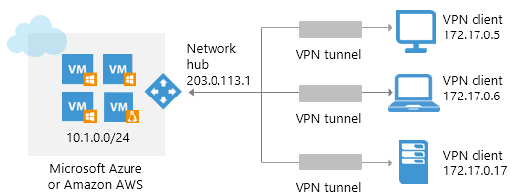

**DNS forwarding**

Since version 2.0, AZ VPN supports DNS forwarding and client configuration:

* Fully automatic detection of DNS settings
* Endpoint clients automatically receive DNS settings to resolve all FQDNs in all connected sites

|  |
| --- |
| **NOTE:** |
| To bring DNS forwarding feature on site configuration an administrator should change configuration of local DNS server, so all requests to domain suffixes of other sites should be forwarded to local VPN site appliance or change DNS server IP address settings individually on each client machine. |

Poornima University, Jaipur B.Tech, Computer Engineering

|  |  |
| --- | --- |
|  | **2019-20** |
|  |  |

**Chapter 3**

**Technological Details/Architecture**

**3.1 Technology Overview**

Unlike S2S connections, P2S connections do not require an on-premises public-facing IP address or a VPN device. P2S connections can be used with S2S connections through the same VPN gateway, as long as all the configuration requirements for both connections are compatible.

### **Deployment models and methods for P2S**

**Azure native certificate authentication**

|  |  |  |
| --- | --- | --- |
| **DES 1** | | |
| **Deployment model/method** | **Azure portal** | **PowerShell** |
| Resource Manager | Check | Check |
| Classic | Check | Supported |

**RADIUS authentication**

|  |  |  |
| --- | --- | --- |
| **DES 2** | | |
| **Deployment model/method** | **Azure portal** | **PowerShell** |
| Resource Manager | Supported | Check |
| Classic | Not Supported | Not Supported |

### **Connections between deployment models**

Azure currently has two deployment models: classic and Resource Manager. If you have been using Azure for some time, you probably have Azure VMs and instance roles running in a classic VNet. Your newer VMs and role instances may be running in a VNet created in Resource Manager. You can create a connection between the VNets to allow the resources in one VNet to communicate directly with resources in another.

### **VNet peering**

We may be able to use VNet peering to create your connection, as long as your virtual network meets certain requirements. VNet peering does not use a virtual network gateway.

### **Deployment models and methods for VNet-to-VNet**

|  |  |  |  |
| --- | --- | --- | --- |
| **DES 3** | | | |
| **Deployment model/method** | **Azure portal** | **PowerShell** | **Azure CLI** |
| Classic | [Check](https://docs.microsoft.com/en-us/azure/vpn-gateway/vpn-gateway-howto-vnet-vnet-portal-classic) | Supported | Not Supported |
| Resource Manager | [Check](https://docs.microsoft.com/en-us/azure/vpn-gateway/vpn-gateway-howto-vnet-vnet-resource-manager-portal) | [Check](https://docs.microsoft.com/en-us/azure/vpn-gateway/vpn-gateway-vnet-vnet-rm-ps) | [Check](https://docs.microsoft.com/en-us/azure/vpn-gateway/vpn-gateway-howto-vnet-vnet-cli) |
| Connections between different deployment models | [Check](https://docs.microsoft.com/en-us/azure/vpn-gateway/vpn-gateway-connect-different-deployment-models-portal) | Check | Not Supported |

* 1. **Design**

**Let us try to understand the concept via certain examples :**

**Case 1 :**

The Point-to-Site VPN gateway connection in this example is for a VNet that is not connected or peered with any other virtual network (VNet1). In this example, clients can access VNet1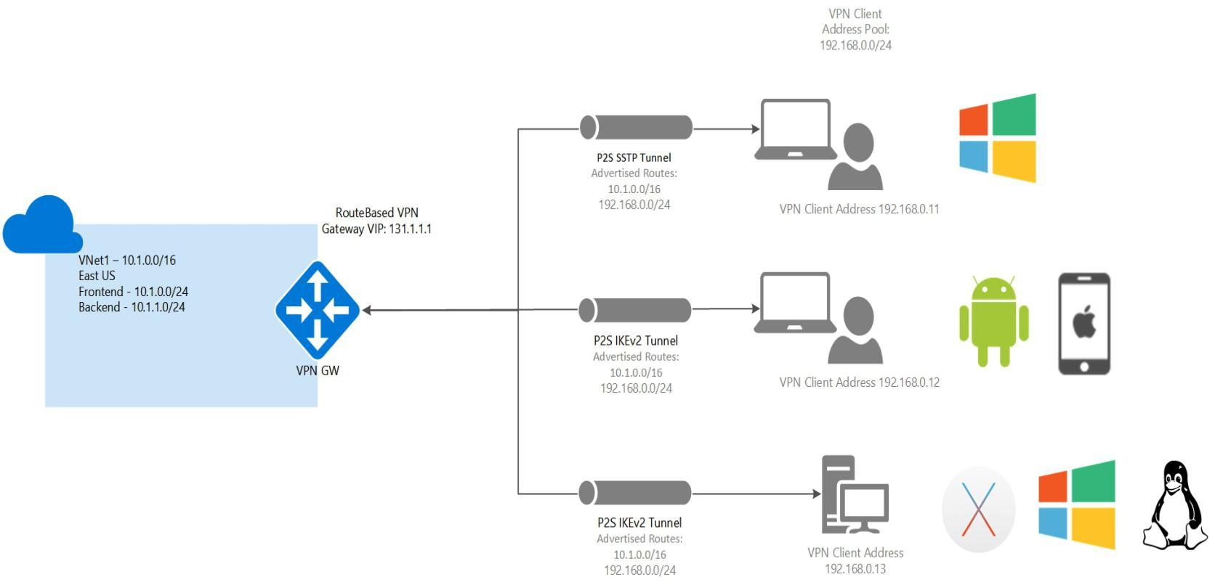

### **Address space**

* VNet1: 10.1.0.0/16

### **Routes added**

* Routes added to Windows clients: 10.1.0.0/16, 192.168.0.0/24
* Routes added to non-Windows clients: 10.1.0.0/16, 192.168.0.0/24

### **Access**

* Windows clients can access VNet1
* Non-Windows clients can access VNet1

**Case 2 :**

## **Multiple peered VNets**

In this example, the Point-to-Site VPN gateway connection is for VNet1. VNet1 is peered with VNet2. VNet 2 is peered with VNet3. VNet1 is peered with VNet4. There is no direct peering between VNet1 and VNet3. VNet1 has “Allow gateway transit” and VNet2 and VNet4 have “Use remote gateways” enabled.

Clients using Windows can access directly peered VNets, but the VPN client must be downloaded again if any changes are made to VNet peering or the network topology. Non-Windows clients can access directly peered VNets. Access is not transitive and is limited to only directly peered VNets.

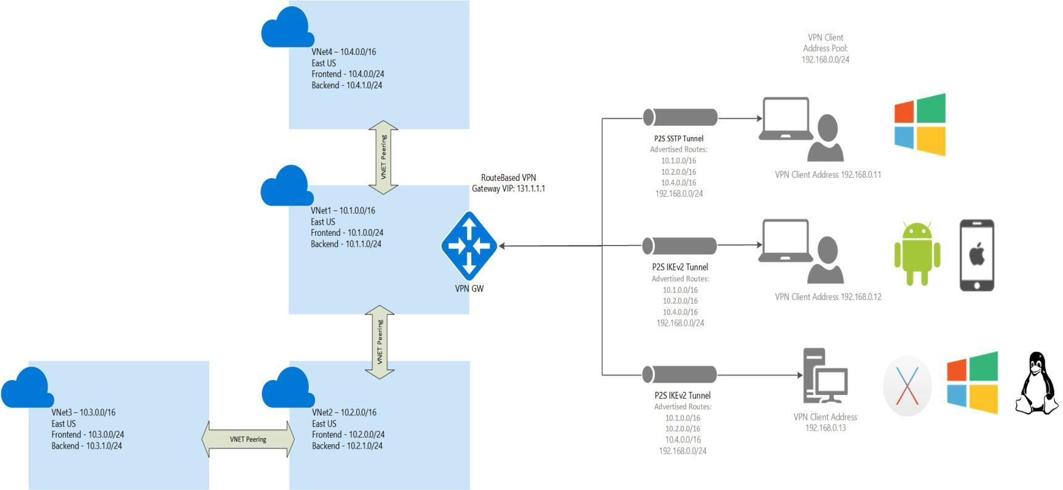

### **Address space:**

* VNet1: 10.1.0.0/16
* VNet2: 10.2.0.0/16
* VNet3: 10.3.0.0/16
* VNet4: 10.4.0.0/16

### **Routes added**

* Routes added to Windows clients: 10.1.0.0/16, 10.2.0.0/16, 10.4.0.0/16, 192.168.0.0/24
* Routes added to non-Windows clients: 10.1.0.0/16, 10.2.0.0/16, 10.4.0.0/16, 192.168.0.0/24

### **Access**

* Windows clients can access VNet1, VNet2, and VNet4, but the VPN client must be downloaded again for any topology changes to take effect.
* Non-Windows clients can access VNet1, VNet2, and VNet4

**3.2 Working Architecture**

## **Protocols P2S Use :**

Point-to-site VPN can use one of the following protocols:

* **OpenVPN Protocol**, an SSL/TLS based VPN protocol. A TLS VPN solution can penetrate firewalls, since most firewalls open TCP port 443 outbound, which TLS uses. OpenVPN can be used to connect from Android, iOS (versions 11.0 and above), Windows, Linux and Mac devices (OSX versions 10.13 and above).
* Secure Socket Tunneling Protocol (SSTP), a proprietary TLS-based VPN protocol. A TLS VPN solution can penetrate firewalls, since most firewalls open TCP port 443 outbound, which TLS uses. SSTP is only supported on Windows devices. Azure supports all versions of Windows that have SSTP (Windows 7 and later).
* IKEv2 VPN, a standards-based IPsec VPN solution. IKEv2 VPN can be used to connect from Mac devices (OSX versions 10.11 and above).

**Note**

IKEv2 and OpenVPN for P2S are available for the Resource Manager deployment model only. They are not available for the classic deployment model.

## **P2S VPN Clients Authentication :**

Before Azure accepts a P2S VPN connection, the user has to be authenticated first. There are two mechanisms that Azure offers to authenticate a connecting user.

### **Authenticate using native Azure certificate authentication**

When using the native Azure certificate authentication, a client certificate that is present on the device is used to authenticate the connecting user. Client certificates are generated from a trusted root certificate and then installed on each client computer. You can use a root certificate that was generated using an Enterprise solution, or you can generate a self-signed certificate.

The validation of the client certificate is performed by the VPN gateway and happens during establishment of the P2S VPN connection. The root certificate is required for the validation and must be uploaded to Azure.

### **Authenticate using native Azure Active Directory authentication**

Azure AD authentication allows users to connect to Azure using their Azure Active Directory credentials. Native Azure AD authentication is only supported for OpenVPN protocol and Windows 10 and requires the use of the [Azure VPN Client](https://go.microsoft.com/fwlink/?linkid=2117554).

With native Azure AD authentication, you can leverage Azure AD's conditional access as well as Multi-Factor Authentication(MFA) features for VPN.

At a high level, you need to perform the following steps to configure Azure AD authentication:

[Configure an Azure AD tenant](https://docs.microsoft.com/en-us/azure/vpn-gateway/openvpn-azure-ad-tenant)

[Enable Azure AD authentication on the gateway](https://docs.microsoft.com/en-us/azure/vpn-gateway/openvpn-azure-ad-tenant#enable-authentication)

[Download and configure Azure VPN Client](https://go.microsoft.com/fwlink/?linkid=2117554)

### **Authenticate using Active Directory (AD) Domain Server**

AD Domain authentication allows users to connect to Azure using their organization domain credentials. It requires a RADIUS server that integrates with the AD server. Organizations can also leverage their existing RADIUS deployment.    The RADIUS server could be deployed on-premises or in your Azure VNet. During authentication, the Azure VPN Gateway acts as a pass through and forwards authentication messages back and forth between the RADIUS server and the connecting device. So Gateway reachability to the RADIUS server is important. If the RADIUS server is present on-premises, then a VPN S2S connection from Azure to the on-premises site is required for reachability.      The RADIUS server can also integrate with AD certificate services. This lets you use the RADIUS server and your enterprise certificate deployment for P2S certificate authentication as an alternative to the Azure certificate authentication. The advantage is that you don’t need to upload root certificates and revoked certificates to Azure.

A RADIUS server can also integrate with other external identity systems. This opens up plenty of authentication options for P2S VPN, including multi-factor options.



## **Client Configuration Requirements :**

**Note**

For Windows clients, you must have administrator rights on the client device in order to initiate the VPN connection from the client device to Azure.

Users use the native VPN clients on Windows and Mac devices for P2S. Azure provides a VPN client configuration zip file that contains settings required by these native clients to connect to Azure.

* For Windows devices, the VPN client configuration consists of an installer package that users install on their devices.
* For Mac devices, it consists of the mobileconfig file that users install on their devices.

The zip file also provides the values of some of the important settings on the Azure side that you can use to create your own profile for these devices. Some of the values include the VPN gateway address, configured tunnel types, routes, and the root certificate for gateway validation.

**3.3 Implementation**

**The said implementation of the technology in form of the project is completed by us in two formats :**

1. LINUX CLIENT
2. WINDOWS CLIENT

**LINUX :**

1. Install strongswan on the system.

sudo apt install strongswan

sudo apt install strongswan-pki

sudo apt install libstrongswan-extra-plugins

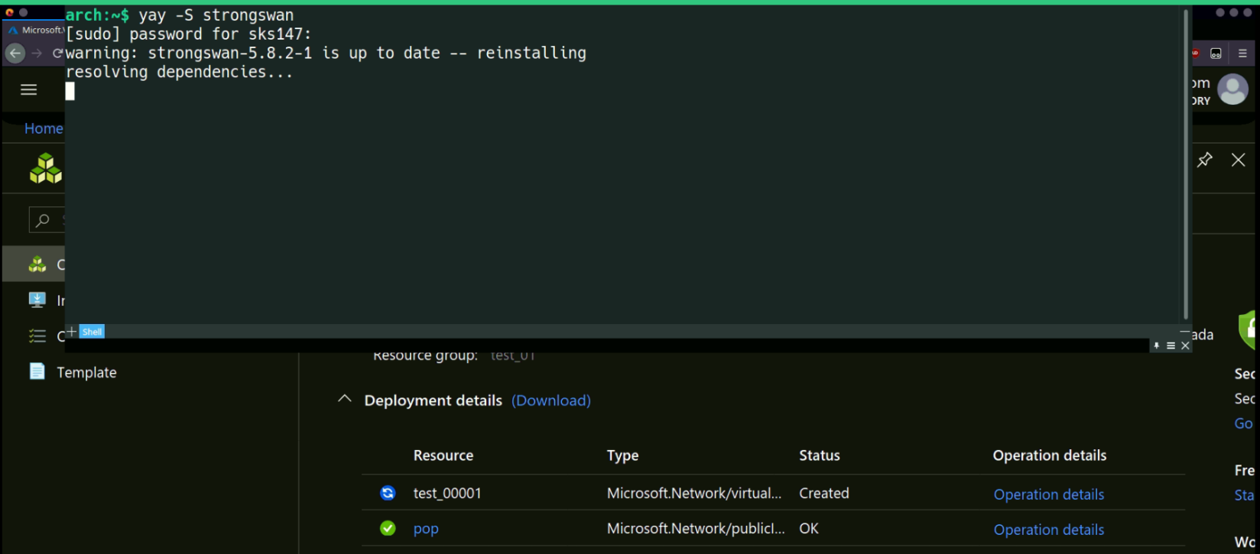

### 2.) Deploy a virtual network

To access your Azure file share and other Azure resources from on-premises via a Point-to-Site VPN, we must create a virtual network, or VNet. The P2S VPN connection you will automatically create is a bridge between our on-premises Linux machine and this Azure virtual network.

The following script will create an Azure virtual network with three subnets: one for your storage account's service endpoint, one for your storage account's private endpoint, which is required to access the storage account on-premises without creating custom routing for the public IP of the storage account that may change, and one for your virtual network gateway that provides the VPN service.

We need to remember to replace <region>, <resource-group>, and <desired-vnet-name> with the appropriate values for your environment.

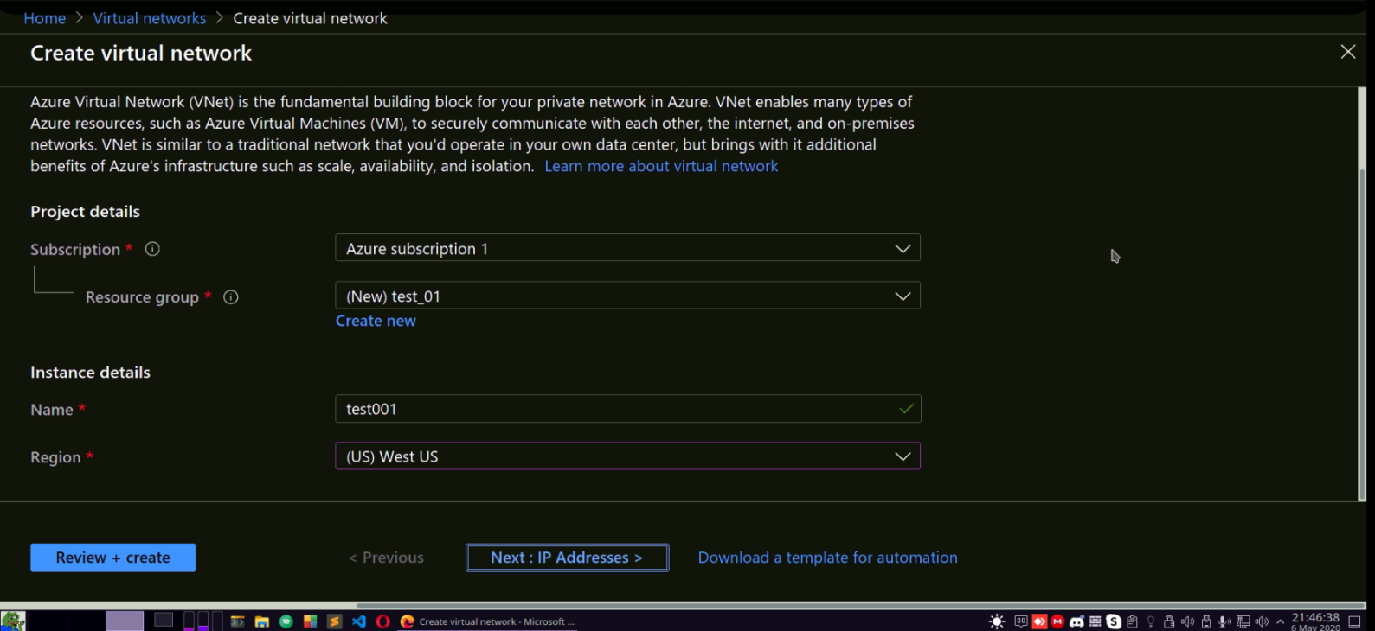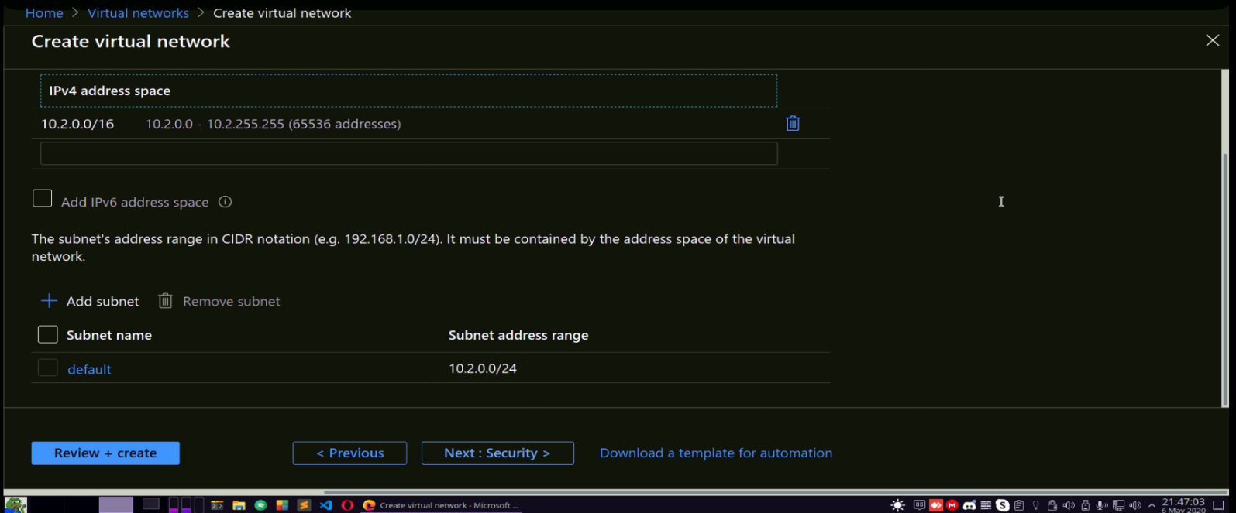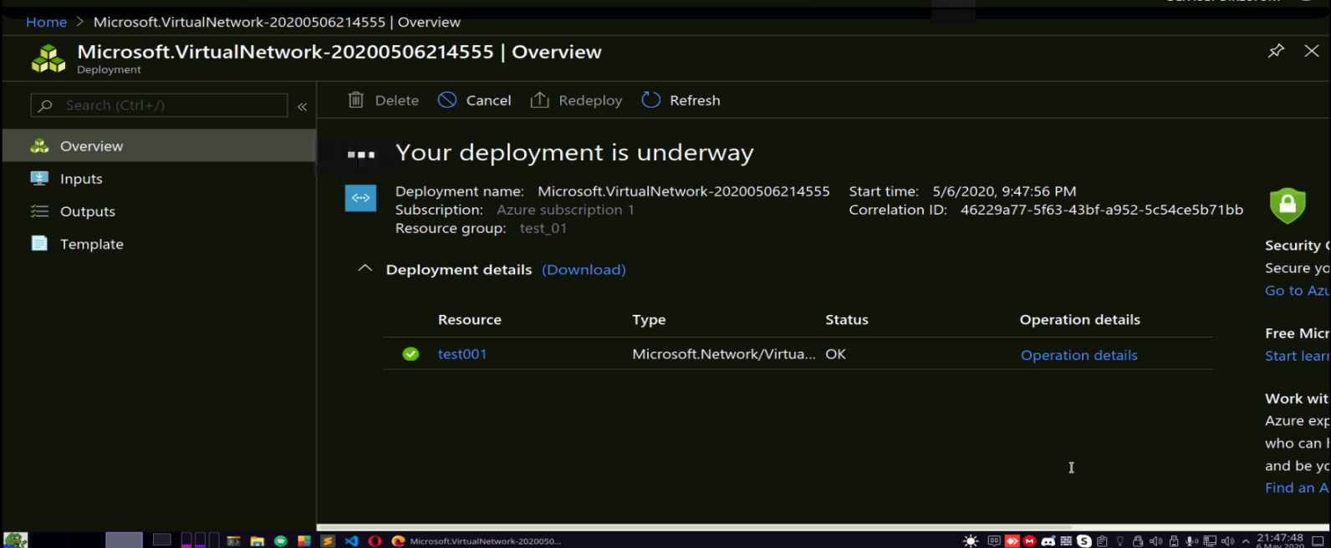

1. ) Adding respective subnets in our virtual network

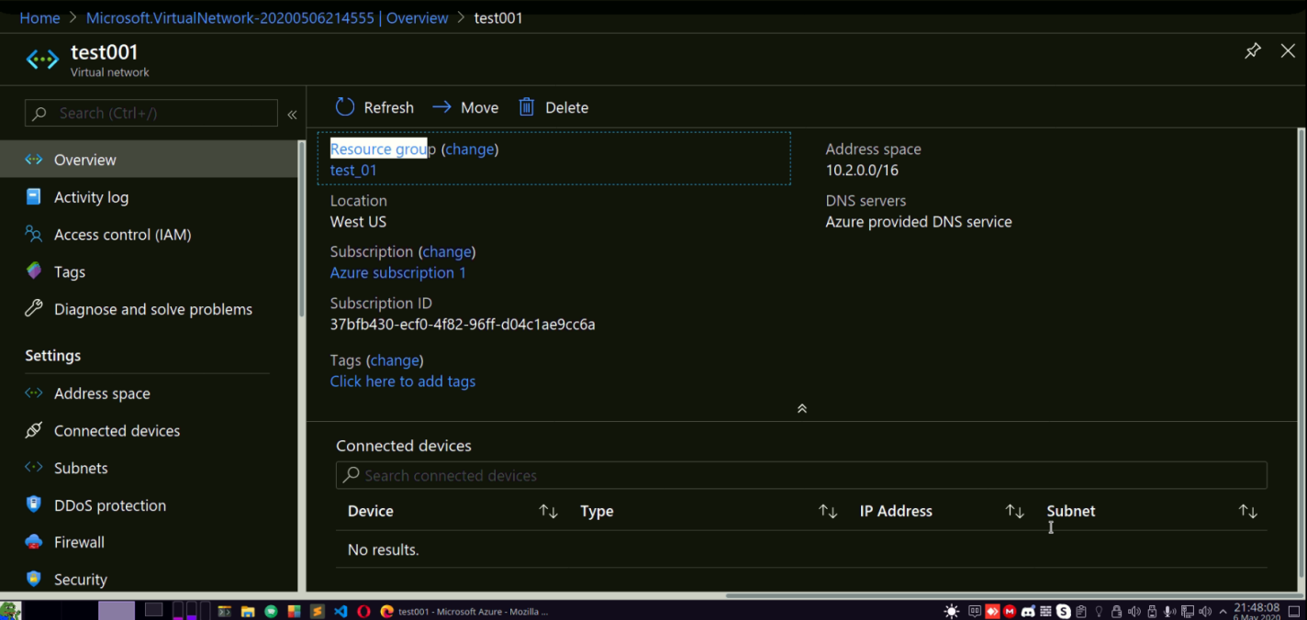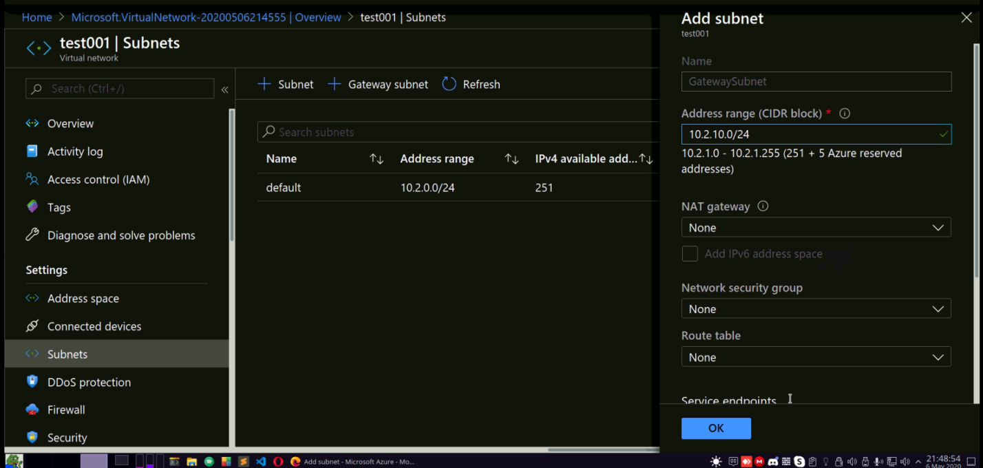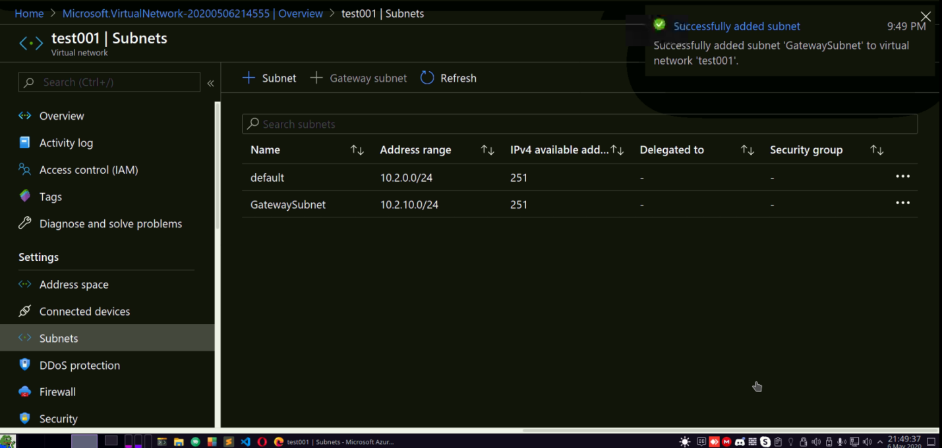

3.) Creating a virtual machine to which our client wants to connect. Note that the ip of the requested connection i.e 192.168.100.4 lies beyond the subnet range in our Vnets so add the specified VM in the private Virtual Network.

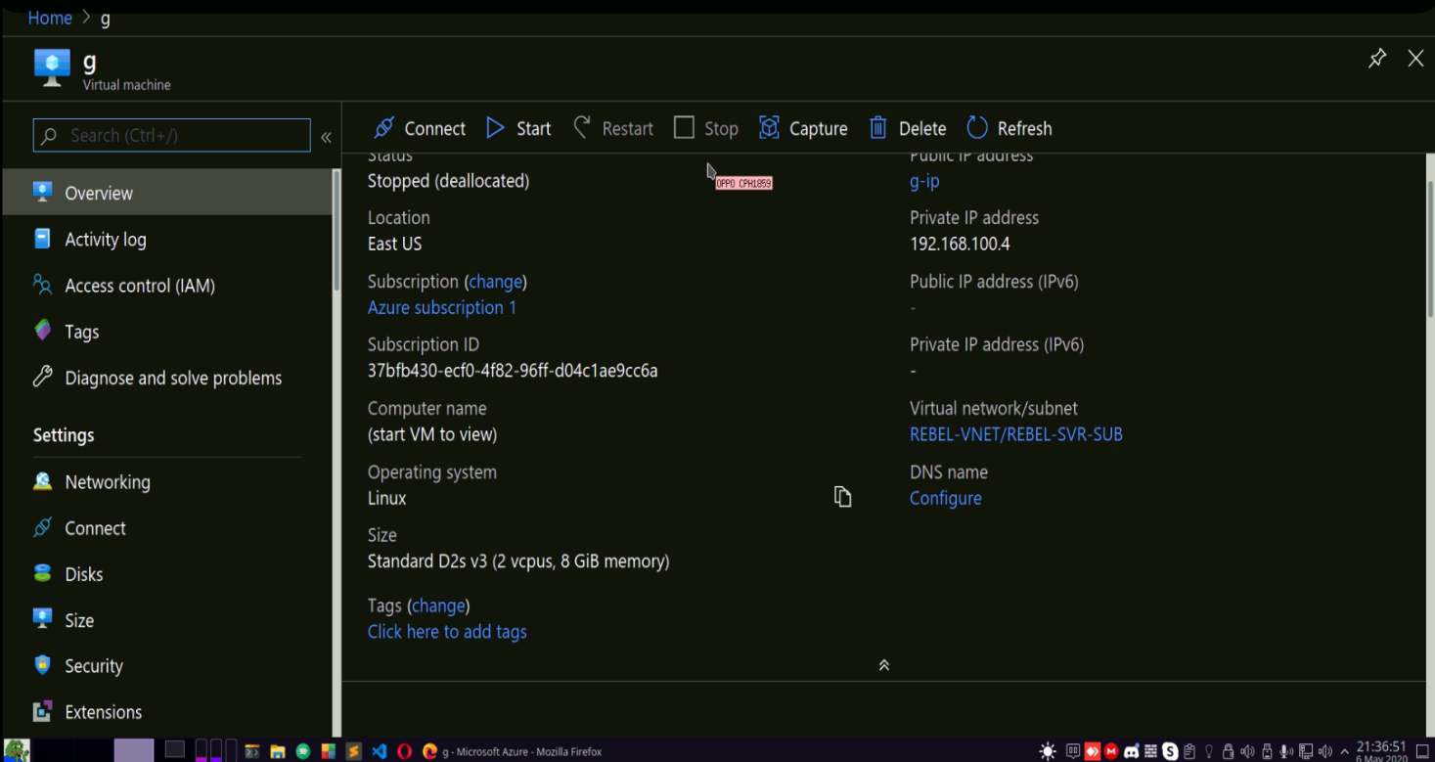

**5.) Creating a Virtual Network Gateway**

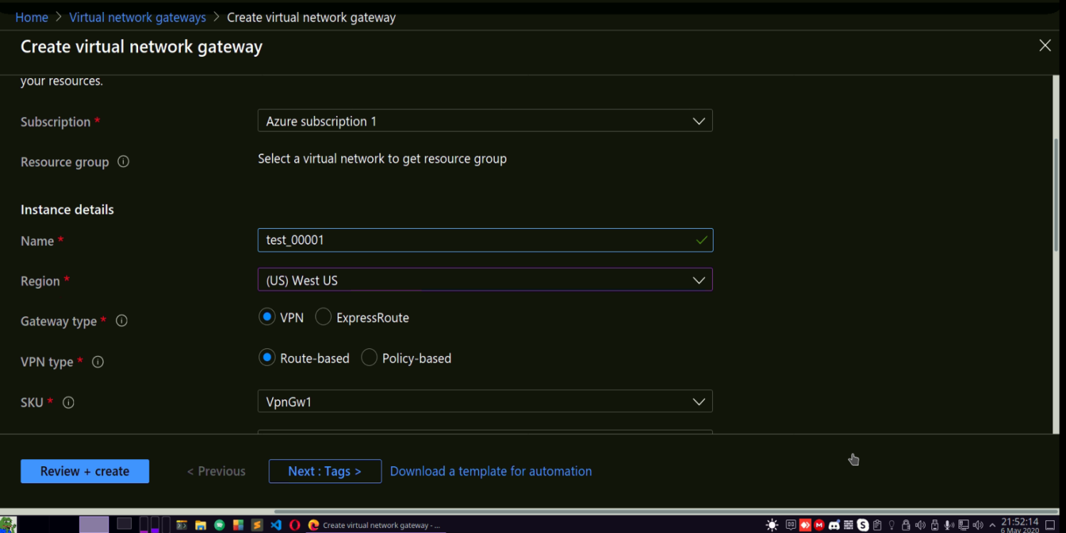

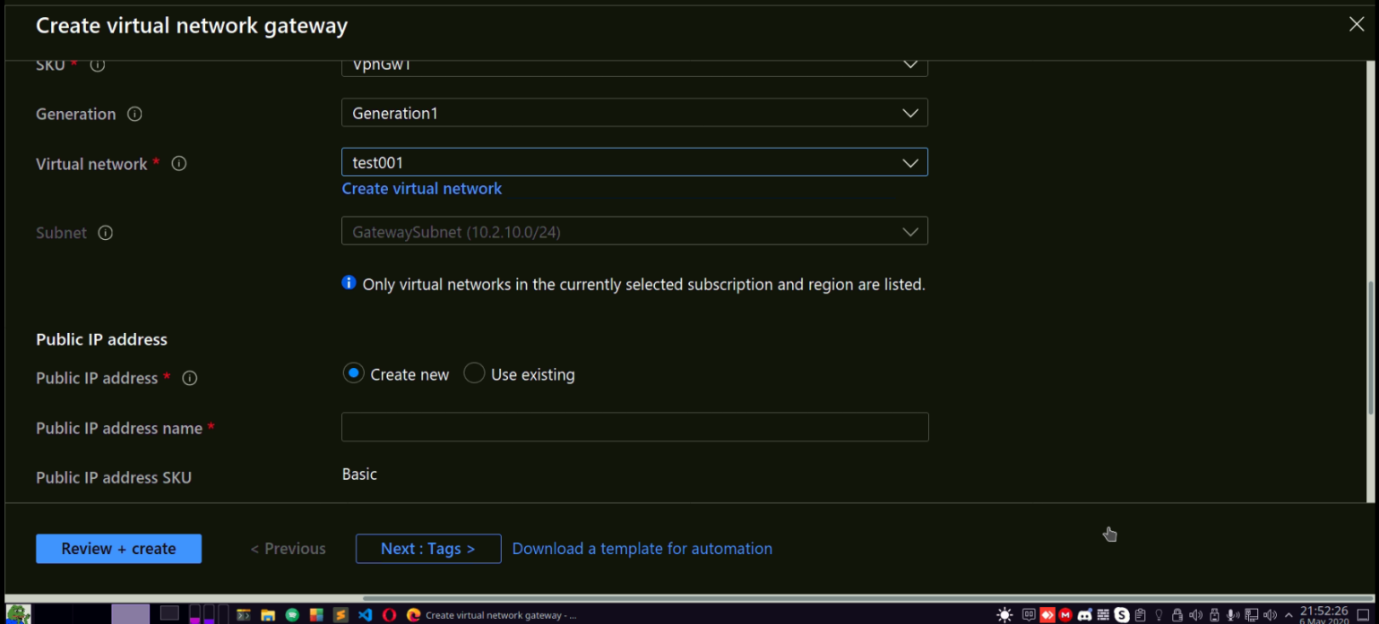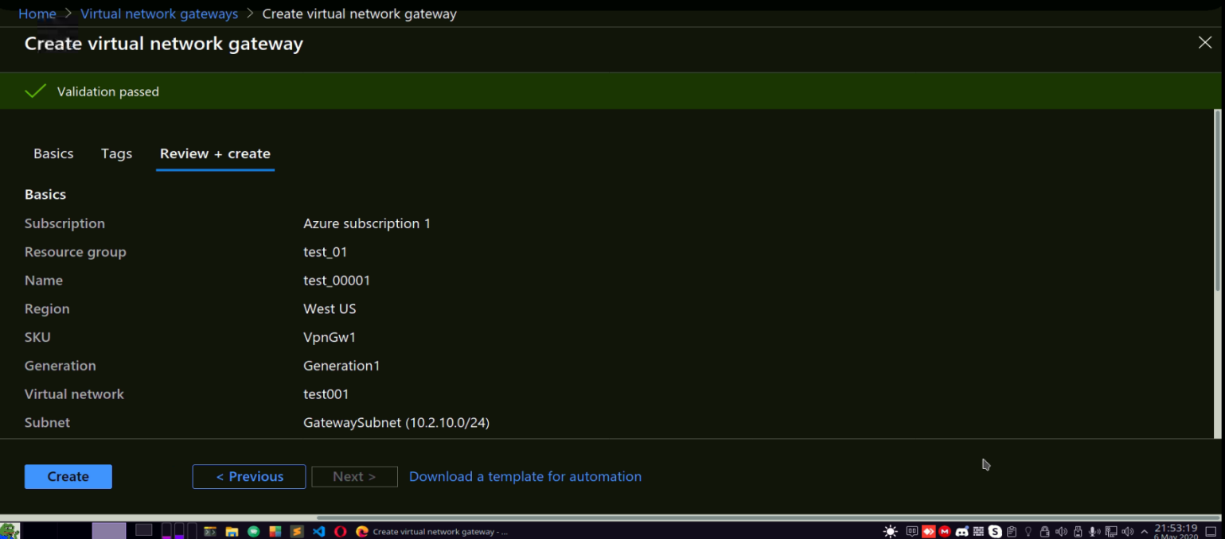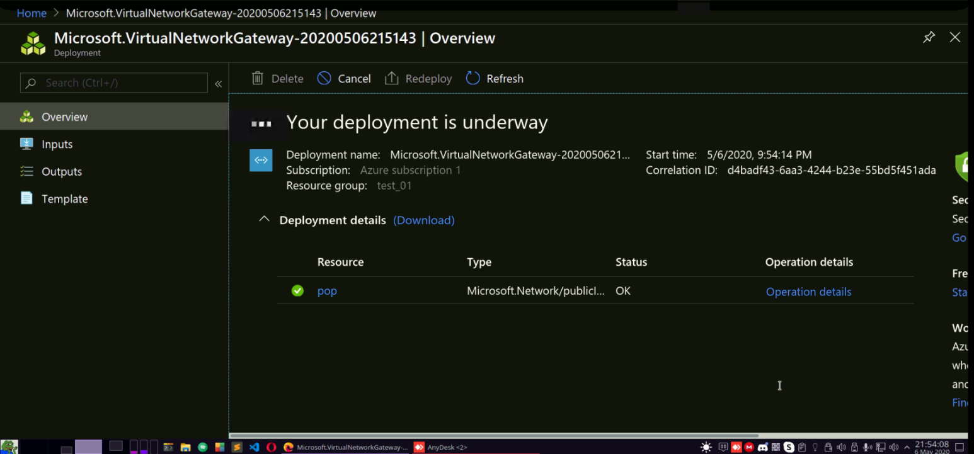

6.) You can use validated certificates and can purchase them over any unifying authority which authenticates the root and client & provides private for export.

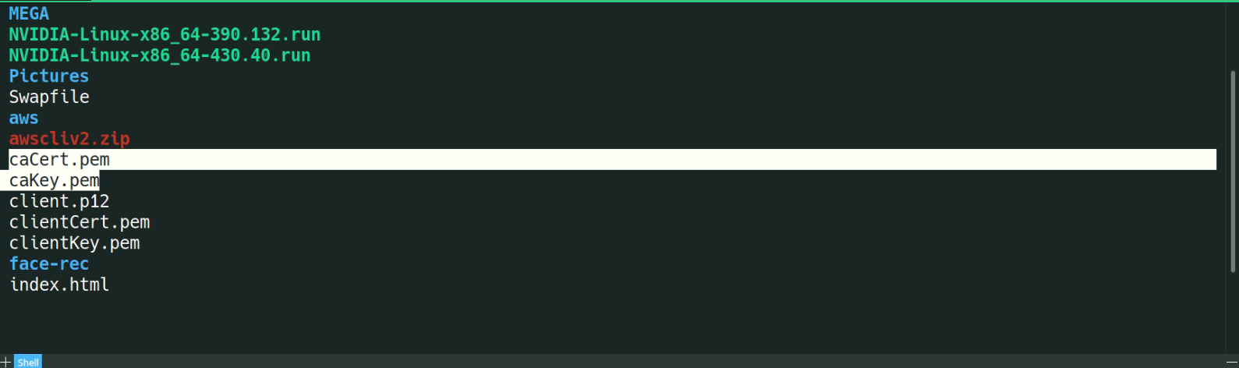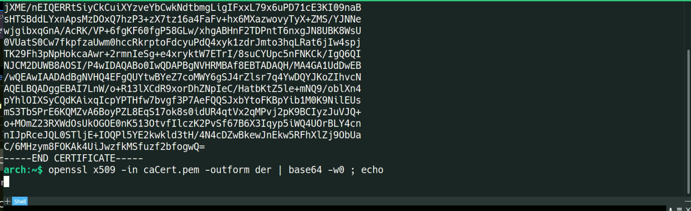

1. ) Now its time to upload the key authentication in the point to site configuration.

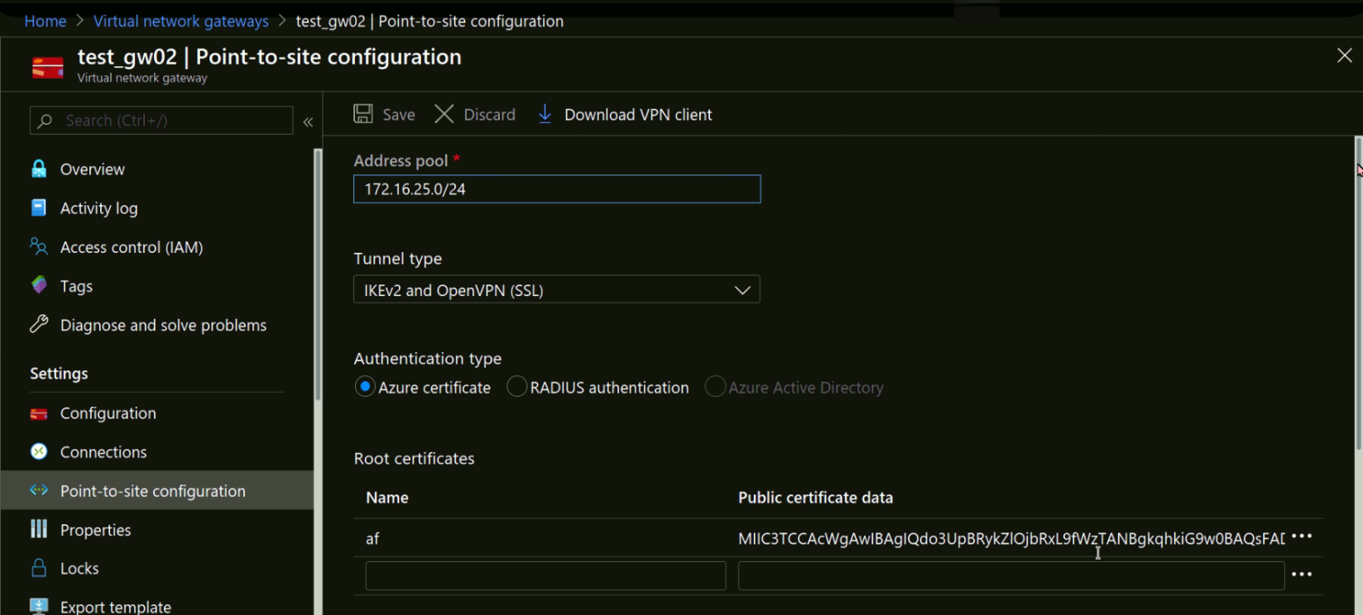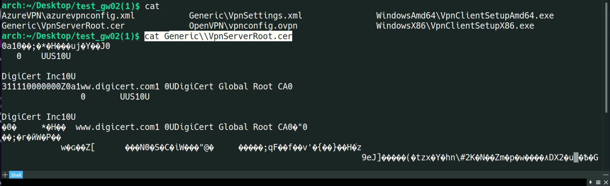

8.) Edit the strongswon Configuration file via editor to accept attributes from **“*Vpnsettings.xml”***

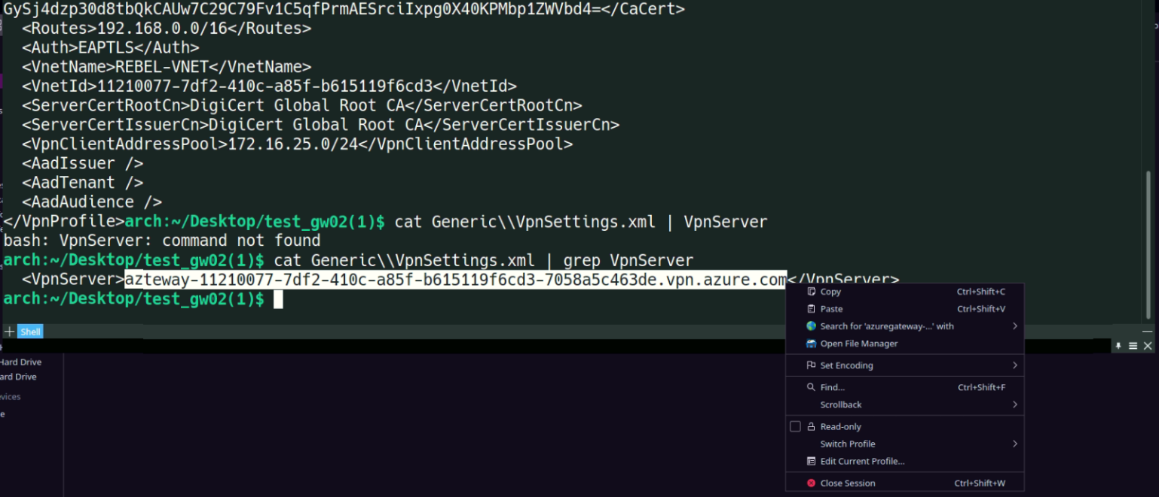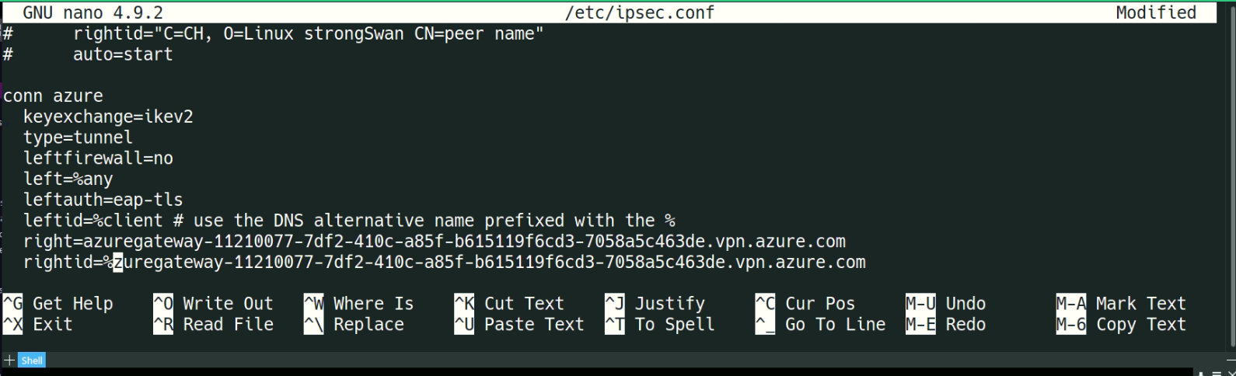

9.) Validate the uplink Certs.

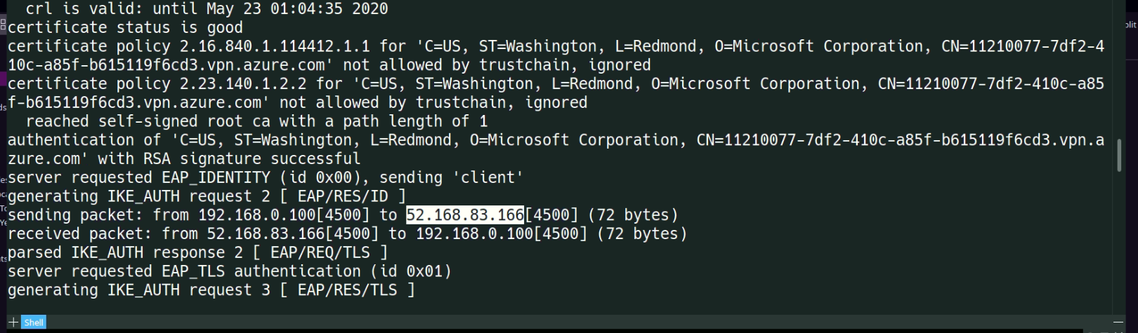

1. ) In terms of vpn client, we already configured that process when we calibrated the XML file settings.
2. ) Initiate the connection via vpn client installed on your linux machine.

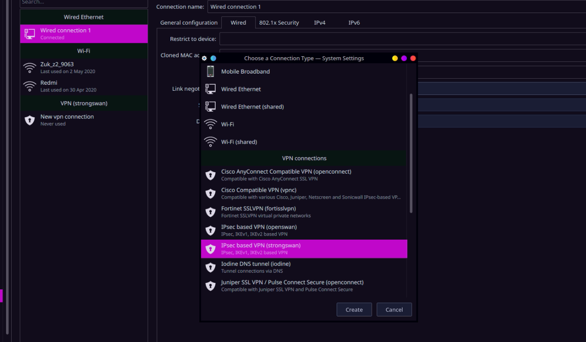

1. ) Connect to the said ip “192.168.100.4” i.e the Ubuntu VM installed on the private network named as “g”.

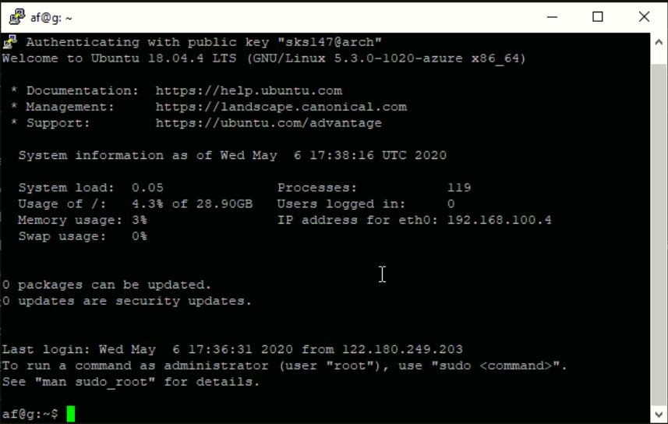

**WINDOWS :**

1. ) Repeat the steps accordingly in terms of VM creation, addition of subnet, establishing virtual network, deploying resources and downloading the VPN client.
2. ) The only difference in the meta is, the certificate generation.
3. ) Gather the IP’s in the network.

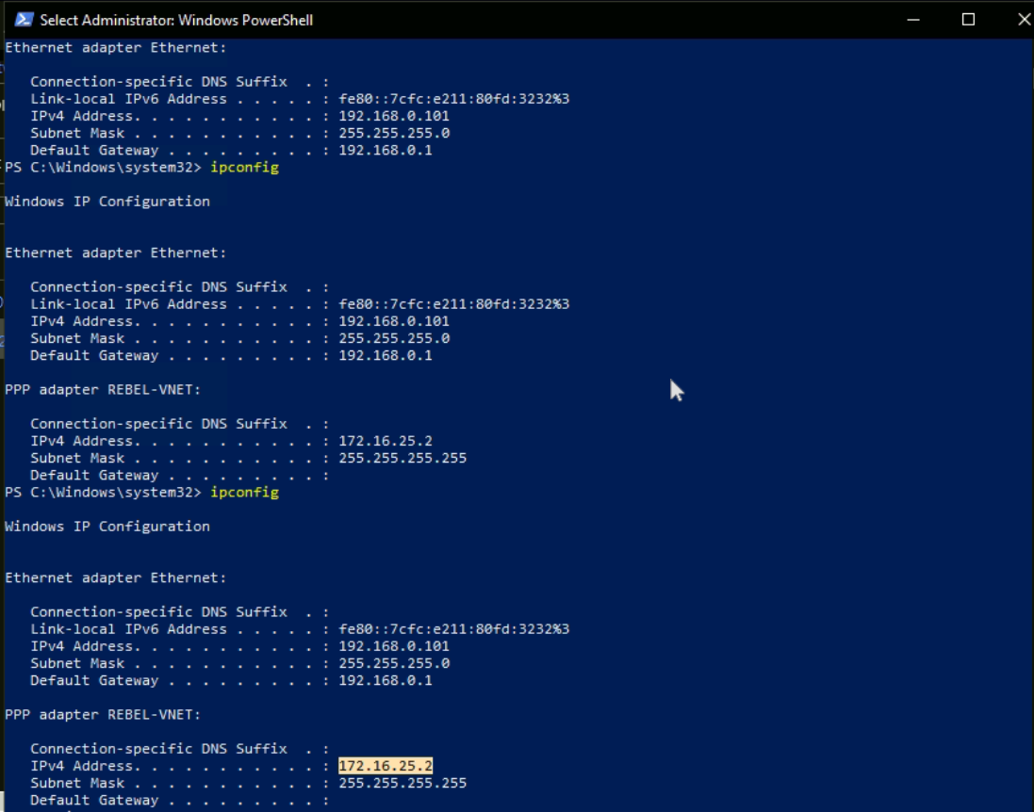

1. ) Generate custom self-signed Certificate.

\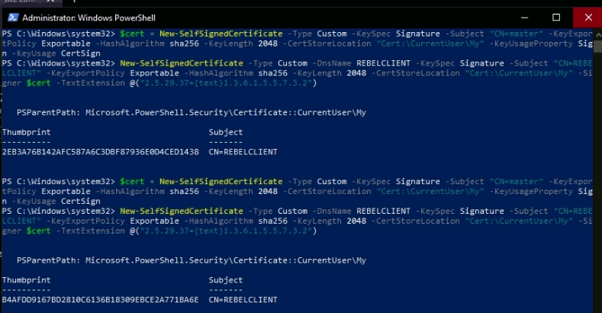

1. ) Export the meta.

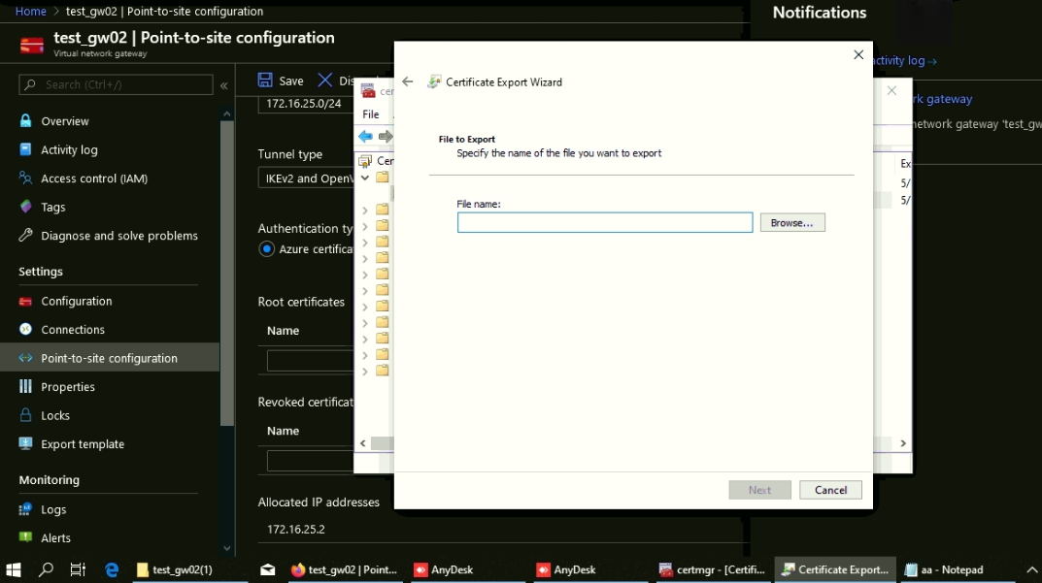

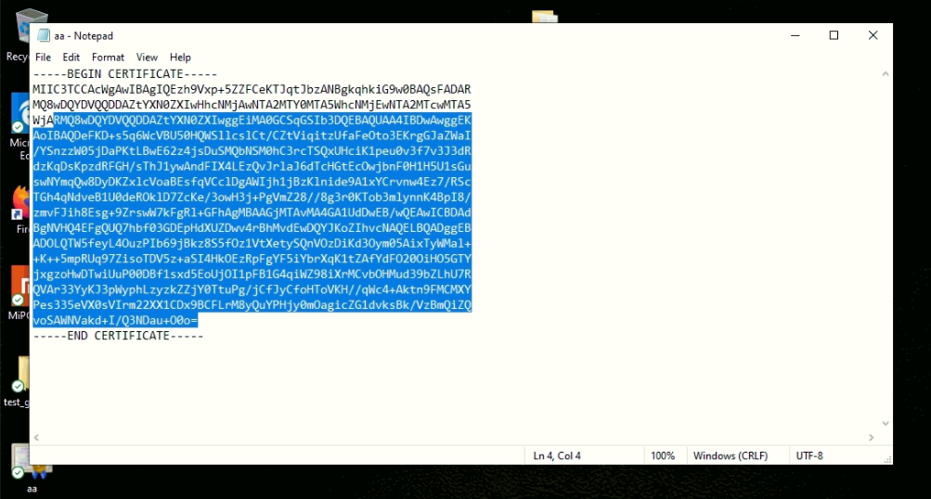

1. ) Generate Key via PuTTy key generator.

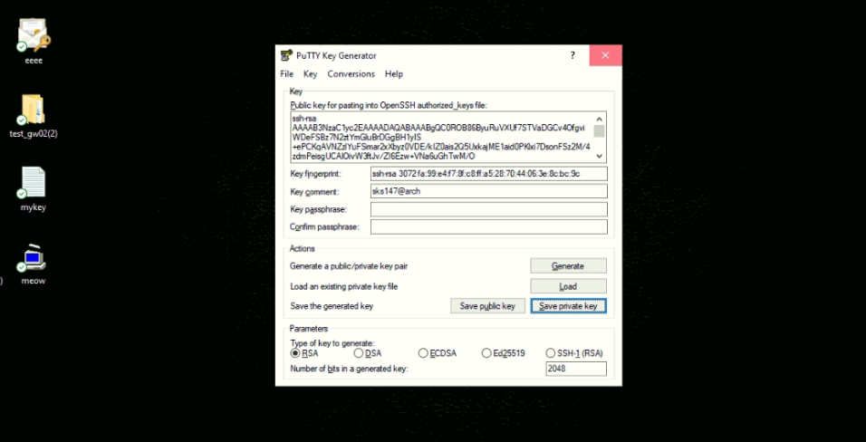

1. ) Load the authenticated key in our <<“new_cert”>> area of gateway 2 made for VM “g”.

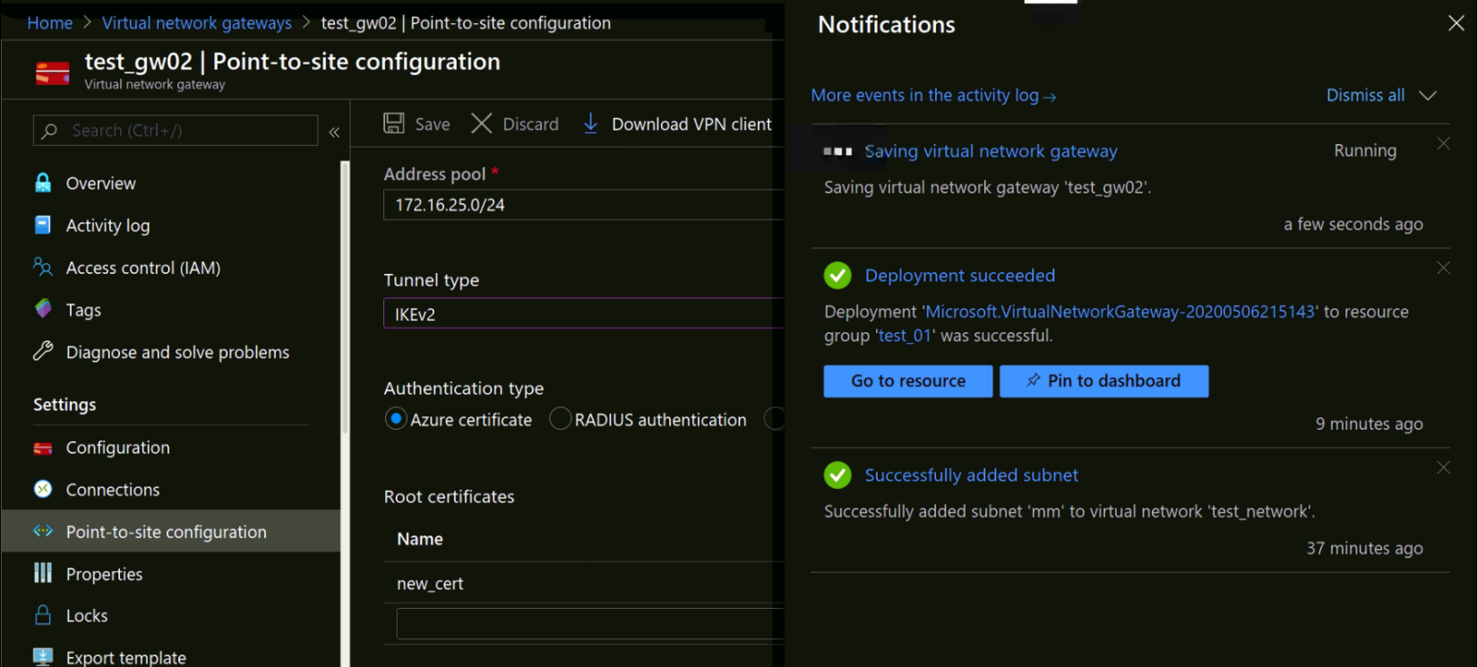

1. ) Connect to the installed VPN connection via VPN Agent.

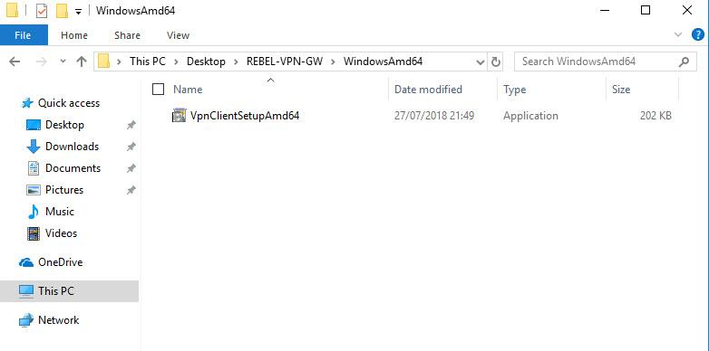

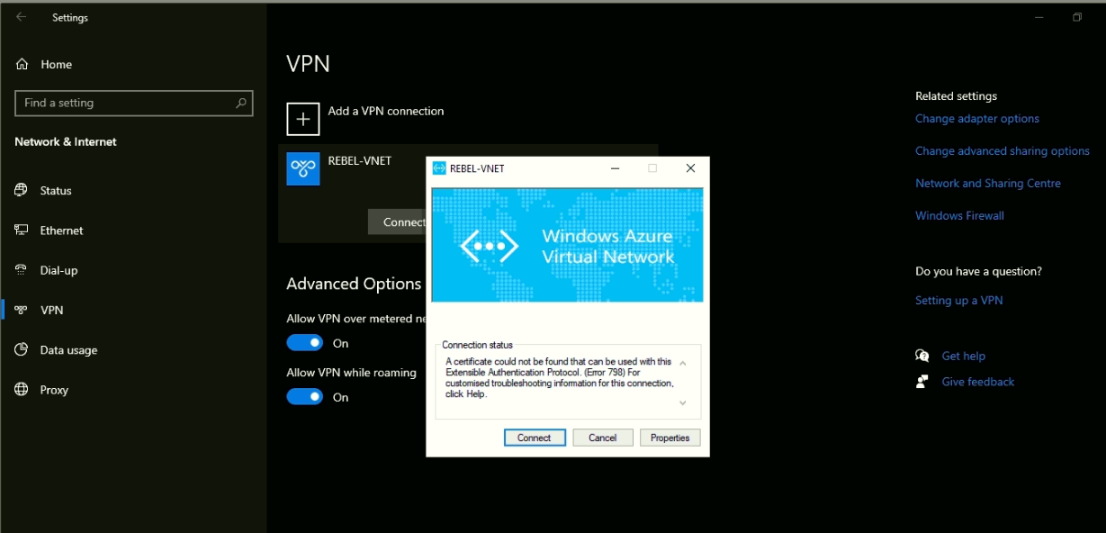

1. ) Try and communicate with the VM present in the Private Virtual Network.

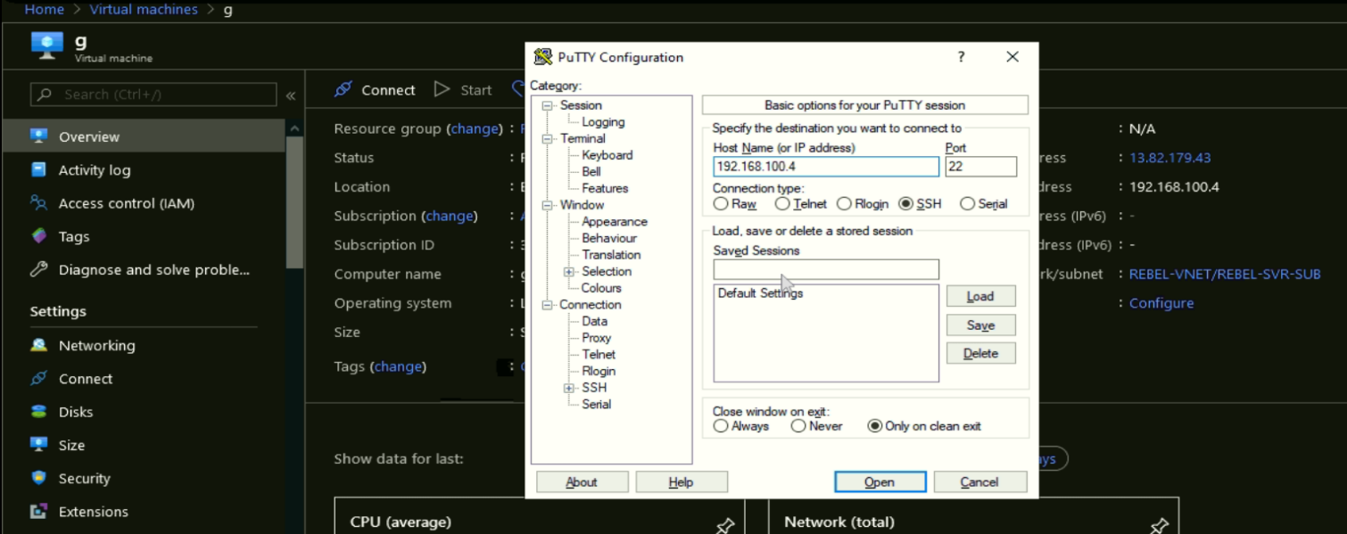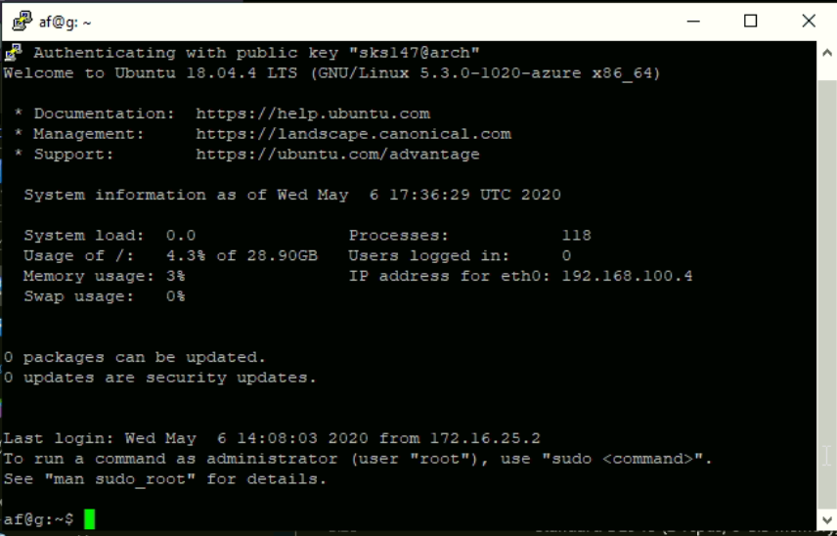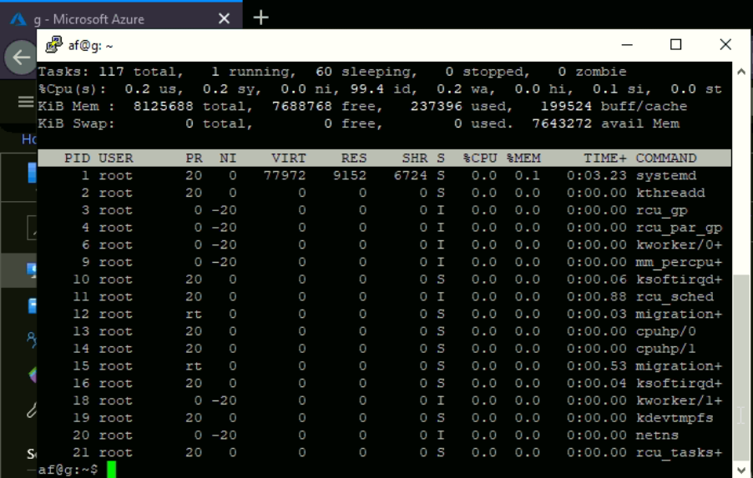

**3.4 Applications**



* We can connect a Web App Service hosted in Azure to a VM hosted also in Azure using a Point to Site VPN.
* One thing that is important to realise is that whilst on the face of it you have a simple connection from one Azure resource to another.
* We must remember that by definition the Point to Site VPN is routing traffic via the Internet.
* Remember your VPN gateway has a public IP address so the VPN tunnel from the App Service is routing onto the Internet and then back again.
* It is also sharing the bandwidth available to the VPN Gateway so you must consider this in our designs. \
* While this configuration will be suitable for multiple scenarios, in others we may be better off using Express Route to provide a more predictable connectivity solution.
* Think of the Point to Site VPN address pool as analogous to the address pool managed by a DHCP server. As clients connect they are allocated an address from the pool. If the pool is exhausted new clients cannot connect.

**LIMITATIONS :**

* they can be relatively slow.
* Connections between point networks and the Azure Virtual Network depend on Internet connectivity.
* There are no guarantees when it comes to Internet connectivity. Even if your ISP provides you with Service Level Agreements (SLAs), they cannot be responsible for all points between your POP and the Azure Virtual Network itself.
* The SLAs only apply to networking issues under Microsoft’s control, similar to the situation to the SLAs you have with your local ISP.
* The performance issue is another important consideration. The performance levels you’ll see for site to site VPNs vary with the hardware involved.
* The Microsoft Azure VPN gateway can support up to 200 Mbps throughput, if you choose to use the Azure high performance gateway (which is going to cost more than that standard VPN gateway). The standard Azure VPN gateway tops out at around 80 Mbps. With speeds like that, you’re really thinking more branch office computing than enterprise data center extension.

**Poornima University, Jaipur** **B.tech, Computer Engineering(CT & IS)**

|  |  |
| --- | --- |
|  | **2019-20** |
|  |  |

**Chapter 4**

**Conclusion & Future scope**

**4.1 Conclusion**

There are scenarios where point to site VPNs are appropriate based on your personal unique security and performance requirements. But for most people, enterprise grade IT shops, you’re going to need to go the route of the dedicated WAN link.

A Point-to-Site (P2S) VPN entryway association gives you a chance to make a protected association with your virtual system from an individual customer PC. A P2S association is set up by beginning it from the customer PC. This arrangement is valuable for remote workers who need to associate with Azure VNets from a remote area, for example, from home or a gathering. P2S VPN is additionally a helpful answer for use rather than S2S VPN when you have just a couple of customers that need to associate with a VNet. This article applies to the Resource Manager arrangement model.

The approval of the customer authentication is performed by the VPN entryway and occurs during the foundation of the P2S VPN association. The root endorsement is required for the approval and must be transferred to Azure.

**4.2 Future scope**



The VPN industry is undergoing a fundamental shift in its perceived primary role but the underlying technology is not moving at the pace we would like. VPNs were created to provide remote access to network resources. Today most people consider VPN a privacy technology. Unfortunately, that is not the case. It takes quite a bit of tweaking and patching to transform traditional remote access VPN software into the sort of privacy service that comes to mind when consumers think of the modern VPN. We expect this to change radically in the near future. We are already starting to see new VPN technologies created with privacy as its main focus, and we expect the pace of new privacy-focused VPN technologies coming to market will increase over the next five years. Two major improvements we expect open source projects to incorporate into their code are anonymous tokenized authentication and protocol obfuscation. Once that happens, VPNs and online privacy in general will see a big step forward.”



**Poornima University, Jaipur** **B.tech, Computer Engineering(CT & IS)**

|  |  |
| --- | --- |
|  | **2019-20** |
|  |  |

**REFERENCES**

The References taken for the development of this report and Project are:

www.youtube.com

[www.Checkspoint.com](http://www.tutorialspoint.com/)

<https://www.futureofeverything.io/future-vpns/>

<https://docs.microsoft.com/en-us/azure/vpn-gateway/vpn-gateway-certificates-point-to-site-linux>

<https://docs.microsoft.com/en-us/azure/vpn-gateway/vpn-gateway-howto-point-to-site-resource-manager-portal>

<https://hamersmithblog.wordpress.com/2017/06/30/connecting-web-apps-to-external-services-point-to-site-vpn-walkthrough/>

[https://docs.microsoft.com/en-us/azure/storage/files/storage-files-configure-p2s-](https://docs.microsoft.com/en-us/azure/storage/files/storage-files-configure-p2s-vpn-linux)

[vpn-linux](https://docs.microsoft.com/en-us/azure/storage/files/storage-files-configure-p2s-vpn-linux)<https://github.com/MicrosoftDocs/azure-docs/blob/master/articles/vpn-gateway/point-to-site-vpn-client-configuration-azure-cert.md>

Avolio, F. M. and Ranum, M. J. 1994. A network perimeter with secure external access. In Internet Society Symposium on Network and Distributed Systems Security, 3-4 Feb. 1994, San Diego, CA, USA. Internet Society, Reston, VA, USA, 109–119.

http://www.ja.net/CERT/Avolio_and_Ranum/isoc94.ps Accessed 2002 Feb 20. Axelsson, S. 1998. Research in Tunnel Generation and Key Formation using Certificates: A survey. Tech. Rep. 98–17, Dept. of Computer Eng. Chalmers Univ. of Tech, SE-412 96 G¨oteborg, Sweden. December.

http://www.ce.chalmers.se/staff/sax/survey.ps Accessed 2002 Feb 20. Bailey, M. L., Gopal, B., Pagels, M. A., Peterson, L. L., and Sarkar, P. 1994. PATHFINDER: Change in Privacy Industry

In 1st Symposium on VPN and their importance, 14-17 November 1994, Monterey, CA, USA. USENIX Association, Berkeley, CA, 115–123

[**http://etd.fcla.edu/etd/uf/2000/ana6124/Master.**](http://etd.fcla.edu/etd/uf/2000/ana6124/Master.pdf)

[**https://docstore.mik.ua/univercd/cc/td/doc/product/iaabu/centri4/user/scf4ch3**](https://docstore.mik.ua/univercd/cc/td/doc/product/iaabu/centri4/user/scf4ch3.pdf)

[**https://www.juniper.net/documentation/en_US/learn-about/P2SEvolution**](https://www.juniper.net/documentation/en_US/learn-about/LA_FIrewallEvolution.pdf)

**Poornima University, Jaipur** **B.tech, Computer Engineering(CT & IS)**